Logic Project

IC Tester

Submitted To:

Eng/ Youssef

Eng/ Dina

Eng/ Marwa

Submitted By:

1. Hady Maher
2. Abdelrahman Mohammed
3. Aisha Mousa
4. Ahmed Adel

**Introduction**

This project test 4 ICs (AND, OR, XOR, NAND) with 2 bit input, We change the main design in project description file.

Our new circuit is designed to escape with the first wrong output, we use 2 ICs with 2 bit counter, 1 * 16 MUX, 1 IC AND, 1 IC OR, 1 IC NOT, 1 IC XOR.

|  |  |
| --- | --- |
| Input 1 | Reset the circuit |

**Input Map**

**Output LEDs Map**

|  |  |
| --- | --- |
| LED 1 | Found flag |
| LED 2 | Not found flag |
| LED 3 & 4 | Number of IC |
| LED 5 | Truth table output |
| LED 6 & 7 & 8 & 9 | Output of tested IC |

**ICs**

|  |  |  |  |
| --- | --- | --- | --- |
| ID | Type | Number | Expansion |
| 74161 | Counter | 2 | 2 |
| 74150 | 16 * 1 MUX | 1 | - |
| 7408 | AND | 1 | - |
| 7404 | NOT | 1 | 3 |
| 7486 | XOR | 1 | - |
| 7432 | OR | 1 | - |

**Main circuit**

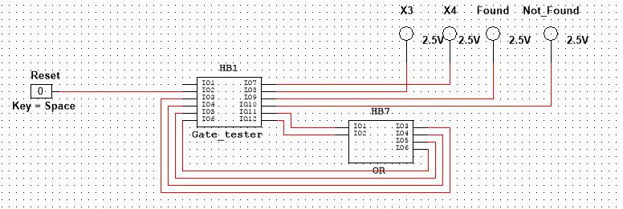

**Gate Tester**

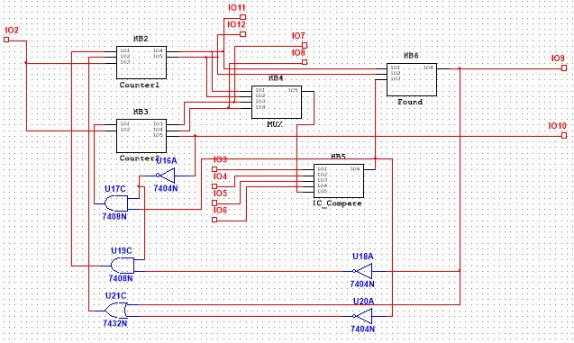

**Counter 1**

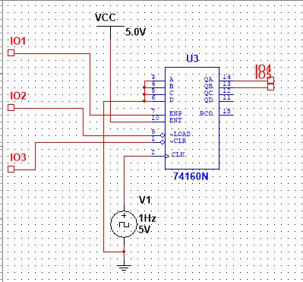

**Counter 2**

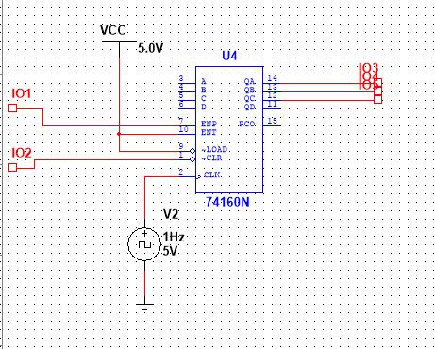

**Truth Table**

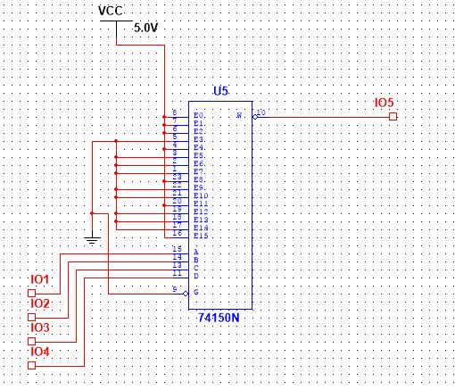

**IC Compare**

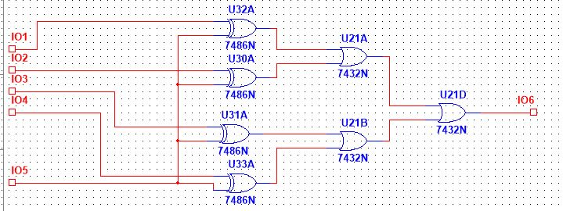

**Found Circuit**

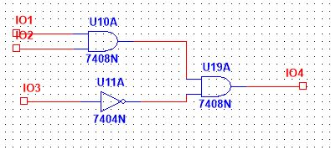

**Project description**